I watched this series of video about making a door:

<https://www.youtube.com/watch?v=Bq-5fTjyWwM&t=751s>

**Basic Information About Wood**

(This information may not correct outside South Korea)

T : When measuring the thickness of wood panel, we use ‘T’. T is exactly same as millimeters. For example, if you buy a wood panel of 6.5T, it means that the panel’s thickness if 6.5 millimeters.

다루끼(*Da-Ru-Ki*) : In South Korea, we call rectangular lumbers as *Da-Ru-Ki*. This is incorrect word to call rectangular lumbers, but conventionally we call these *Da-Ru-Ki*. Normally, Da-Ru-Ki’s width is 28mm * 28mm. You can cut *Da-Ru-Ki* into different sizes.

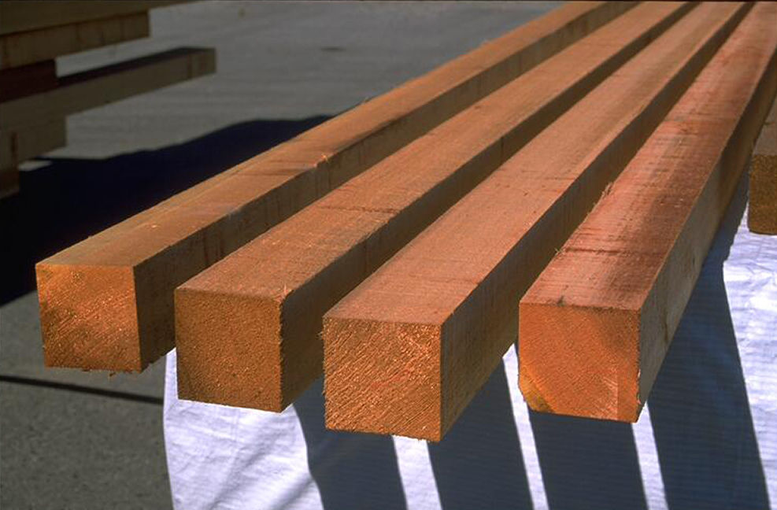

*Da-Ru-Ki*

**Step 1. Make a Wood Frame**

A door is not made of one single wood panel. If you make a door using only one single panel, the door will weigh too much. Therefore, I used two panels and connected them using rectangular lumbers (Picture 1.1). In this way, I could reduce weight while making the door robust. First, apply bond to rectangular lumbers and stick them to one panel. After few minutes, drive nails into the lumbers to fix them. In most cases, rectangular lumbers are bent. To stretch them straight, you have to drive more nails one by one more densely.

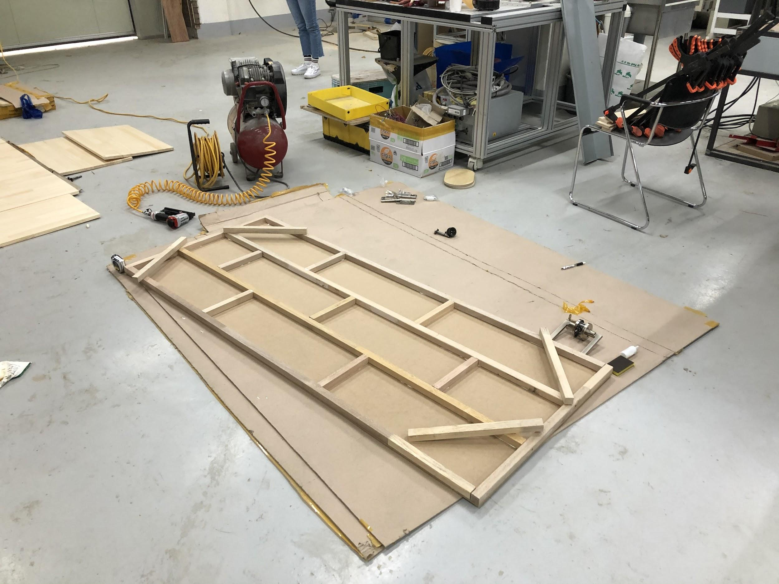

**Step 2. Carve the Pattern**

Make a pattern using Adobe Illustrator and carve the pattern with Shopbot. Shopbot automatically follows the pattern you made and carve the wood panel using a screw. It normally takes a long time to carve, so you should consider the time.

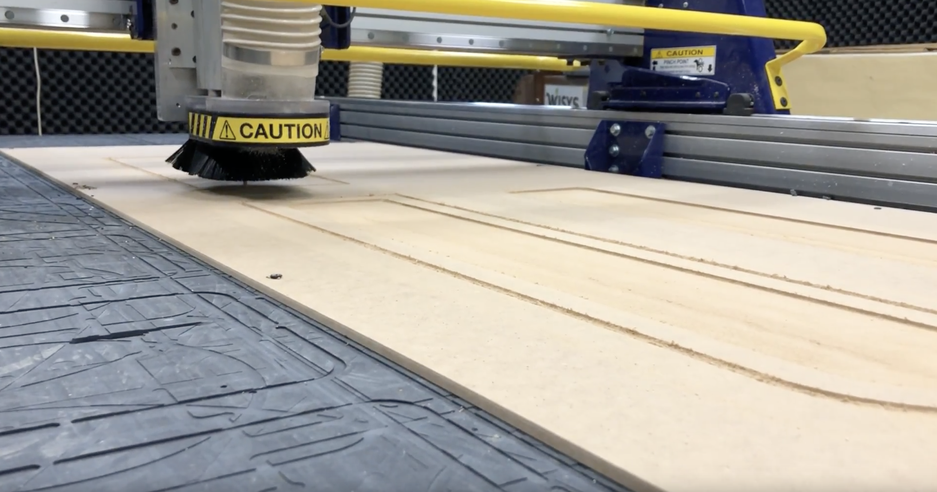

**Step 3. Paint the Door**

After the door is made, paint the door using a roller. It is important to paint the door in same direction. Since it is not easy to remove the paint once it is dried, spread vinyl or newspapers under the door before you start painting.

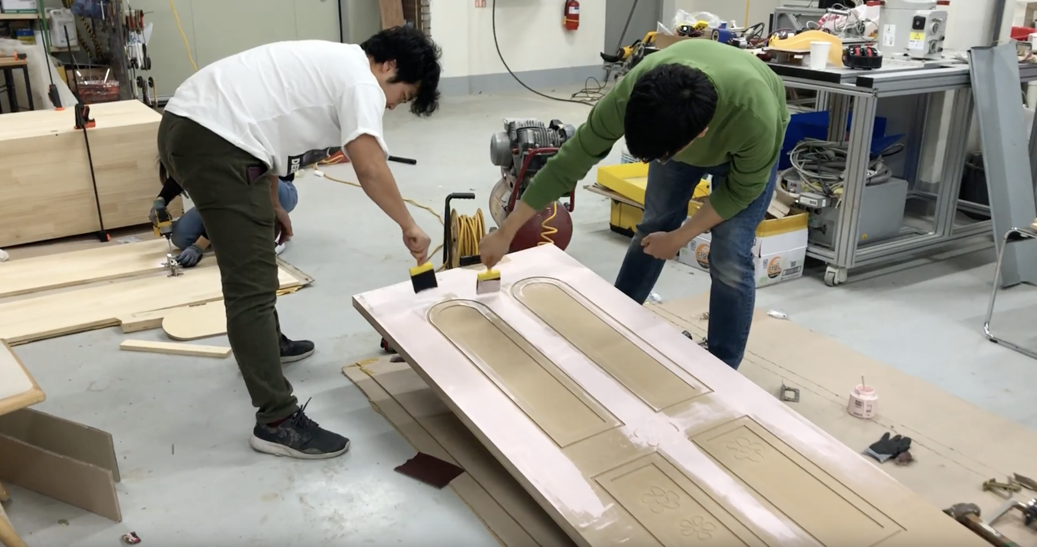

**Step 4. Stand the Door**

Last step is standing the door. Make two wood beams and put three hinges. I recommend using ‘이지 경첩 (Easy Hinge)’ because you don’t need to cut the surface of the door to put hinges on the door. Before you put hinges, watch tutorials first to prevent mistakes.

(<https://www.youtube.com/watch?v=S9O1Si3Dykk>)

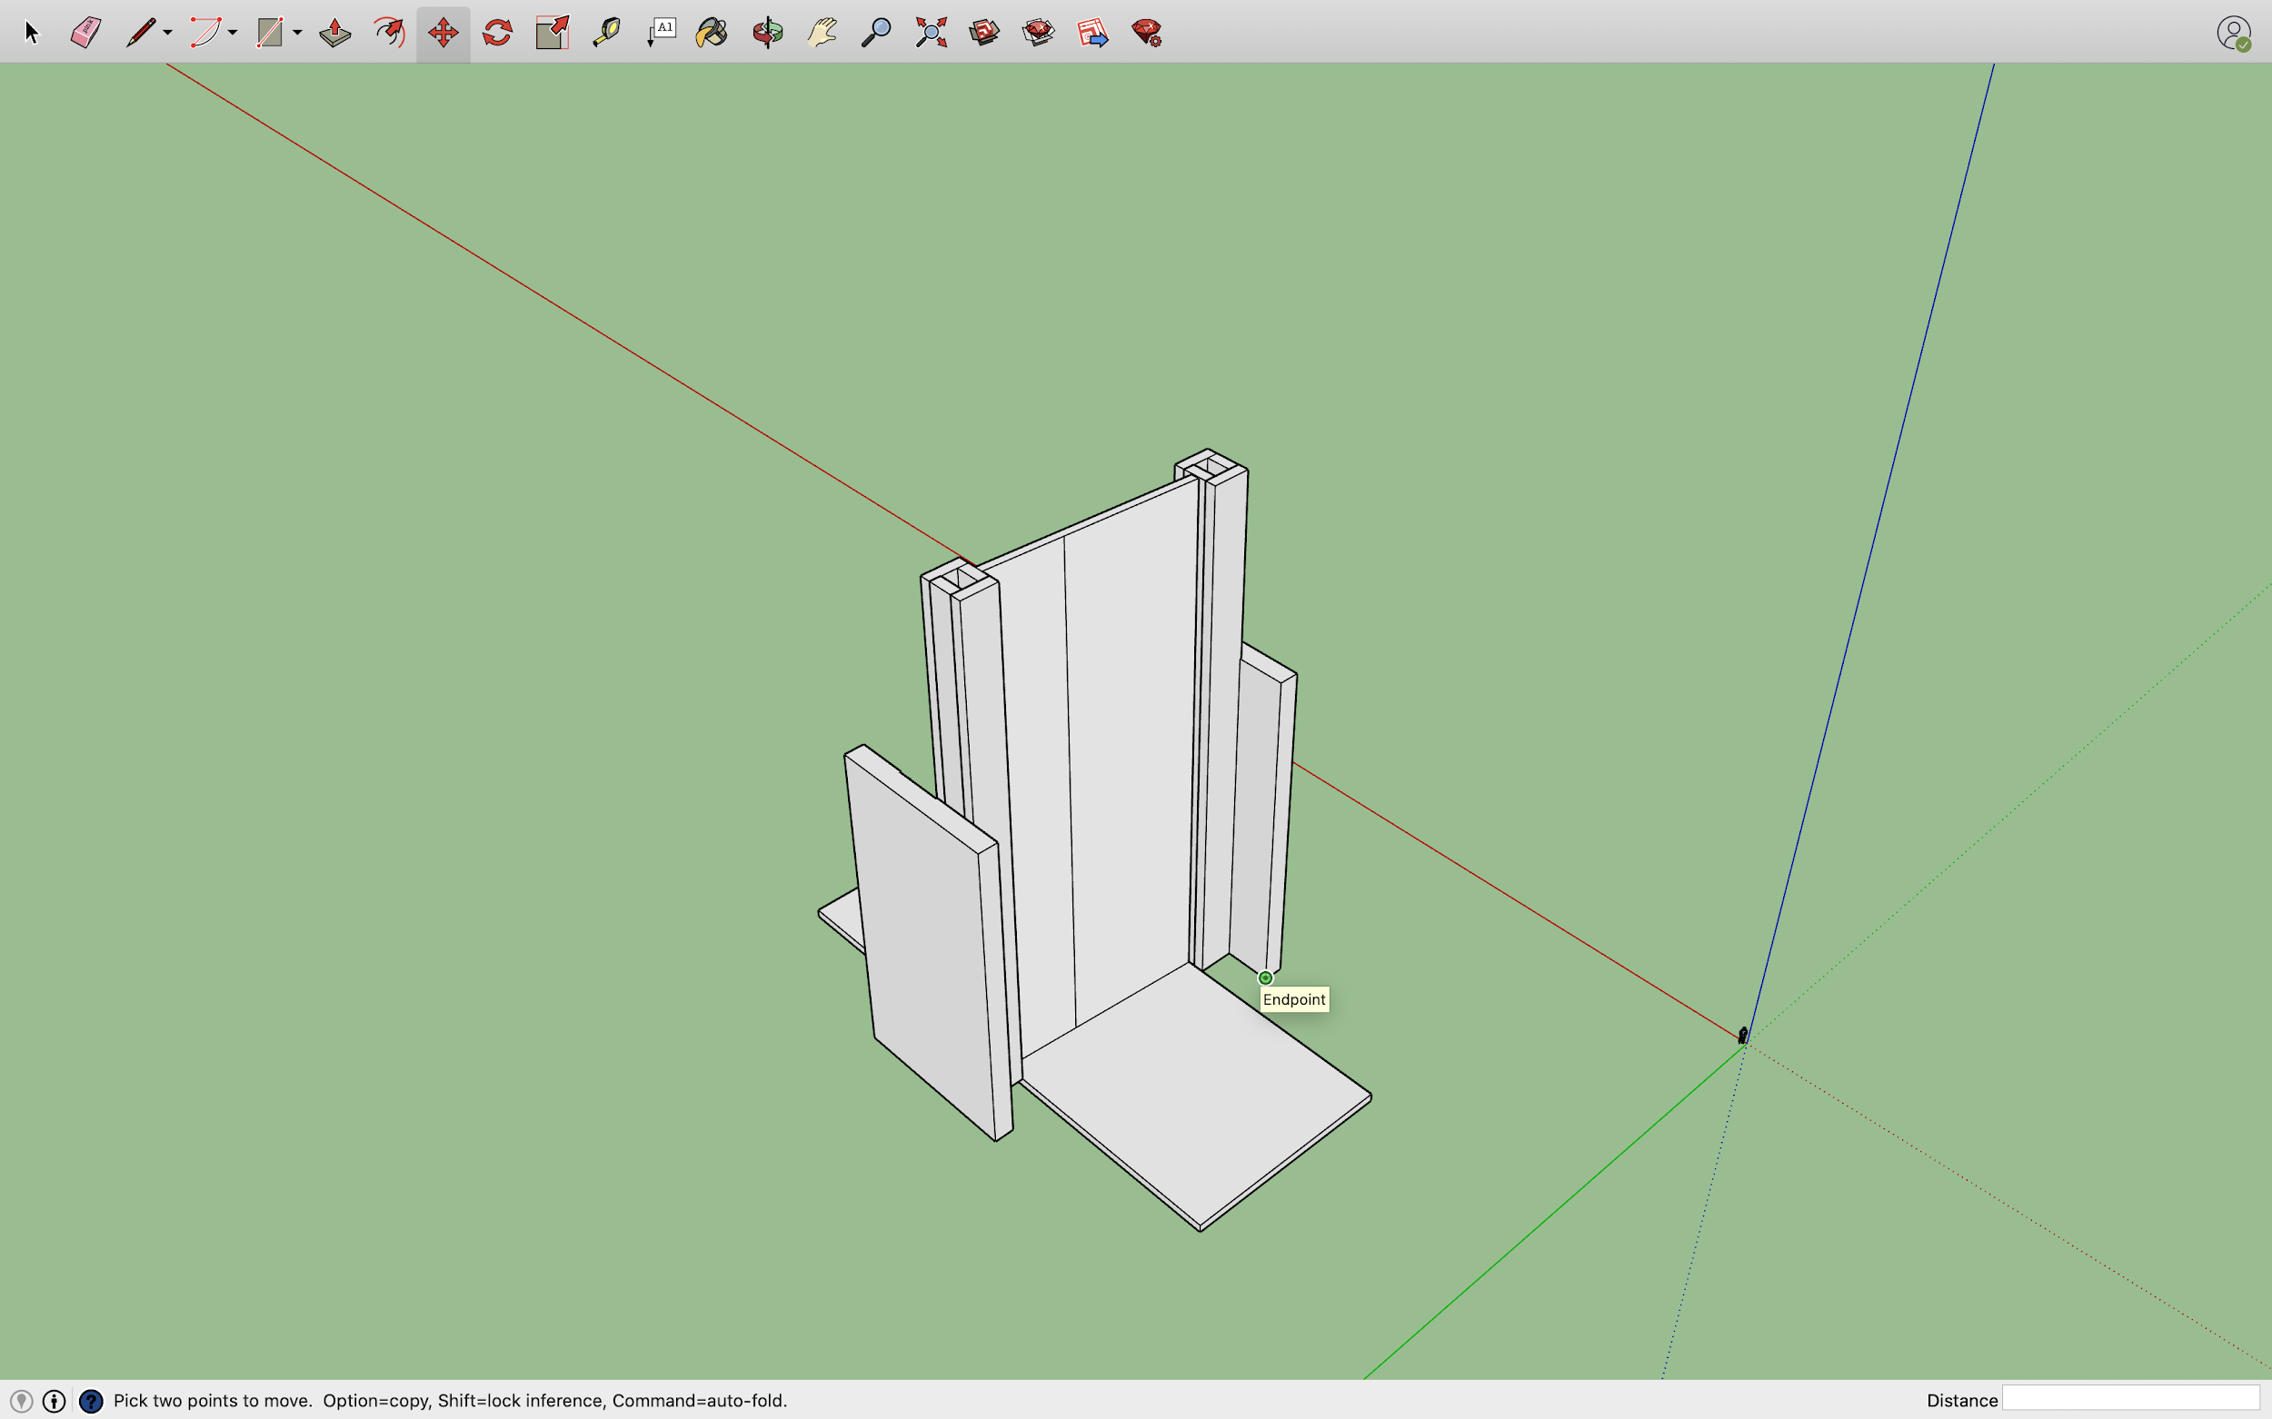

**Finished Door**

